SKILL-3 WEEK
Task-1
TO Apply Single Quotes, Preserve Literal Content, Ignore Variable Expansion, Store Quoted Strings, Validate Parsing Results, Test Edge Cases

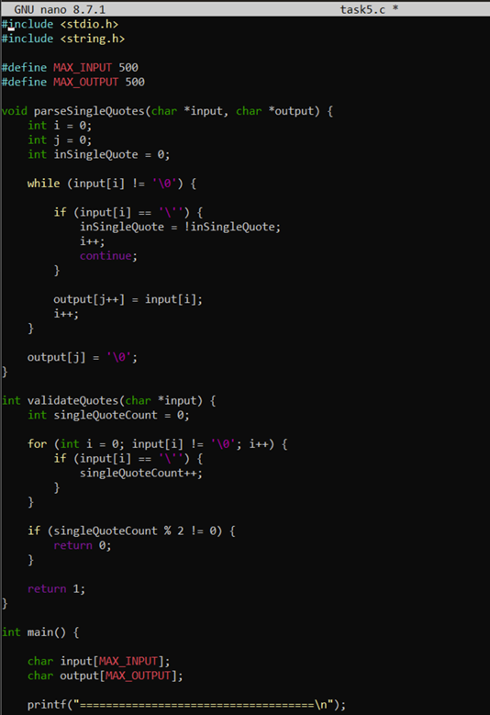

Output:
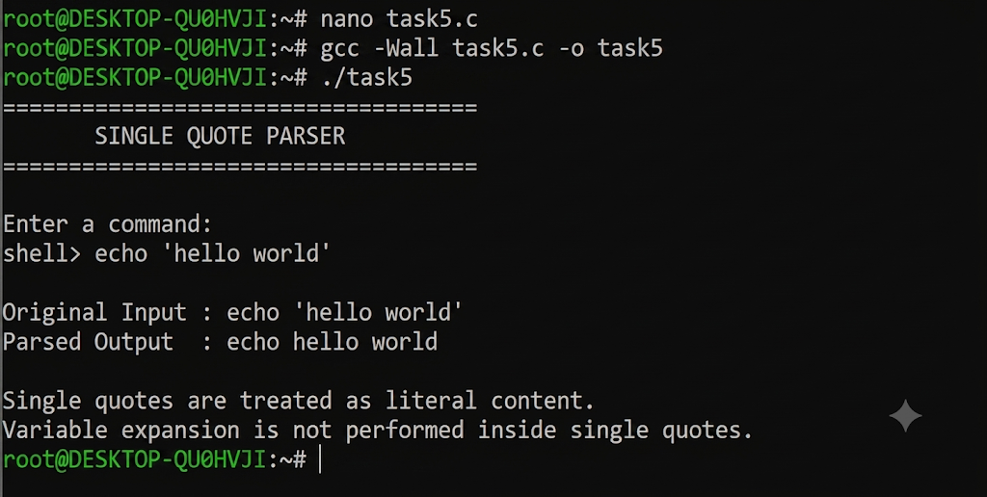

Report: In this task, I implemented handling of single quotes in a shell command using C. The text inside single quotes was treated as literal content, so spaces and special characters were preserved. Variable names such as $HOME were not expanded. The program also checked whether the single quotes were properly closed and displayed an error for unmatched quotes. Different inputs were tested to verify the parsing results.
Task-2
To Apply Double Quotes, Preserve Spaces, Allow Variable Expansion, Parse Nested Tokens, Validate Outputs, Test Quoted Commands

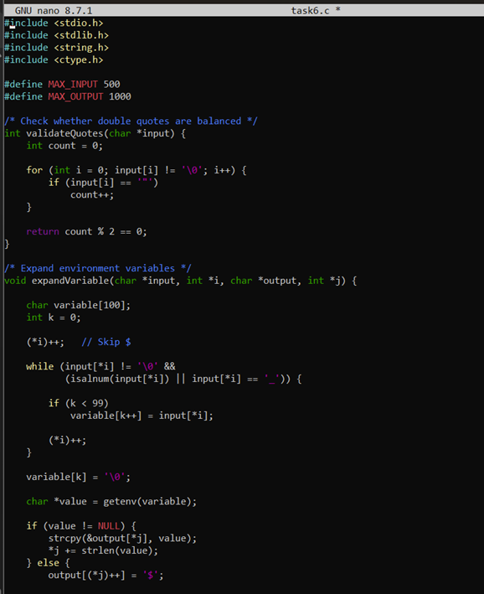

Output:

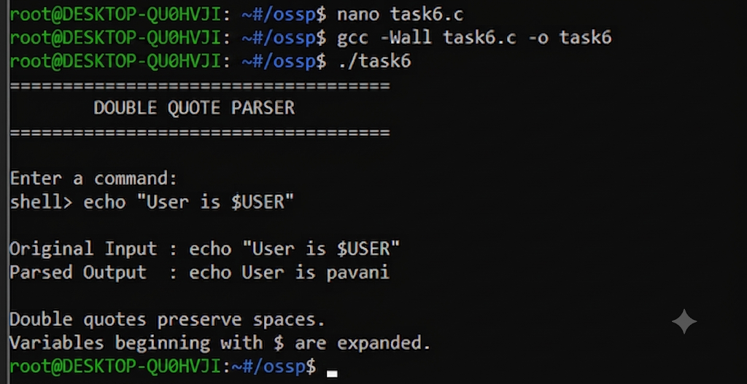

Report: In this task, I implemented double quote handling in C. Double quotes were used to preserve spaces within a command while allowing environment variables such as $USER and
$HOME to be expanded. The program checked for unmatched double quotes and displayed the parsed output. Different quoted commands were tested to verify that spaces and variables were handled correctly.

Session-6 Task-1
To Create Process Escape Sequences, Handle Escaped Spaces, Escape Special Symbols, Preserve Characters, Validate Parser Output, Test Complex Inputs

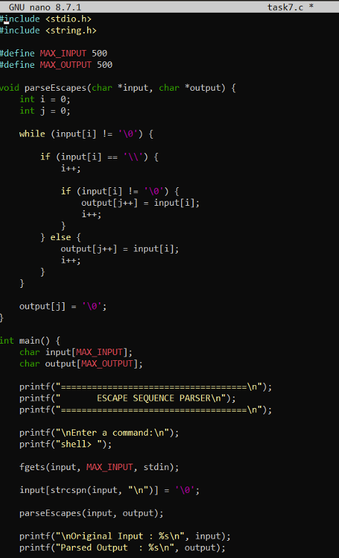

OUTPUT:

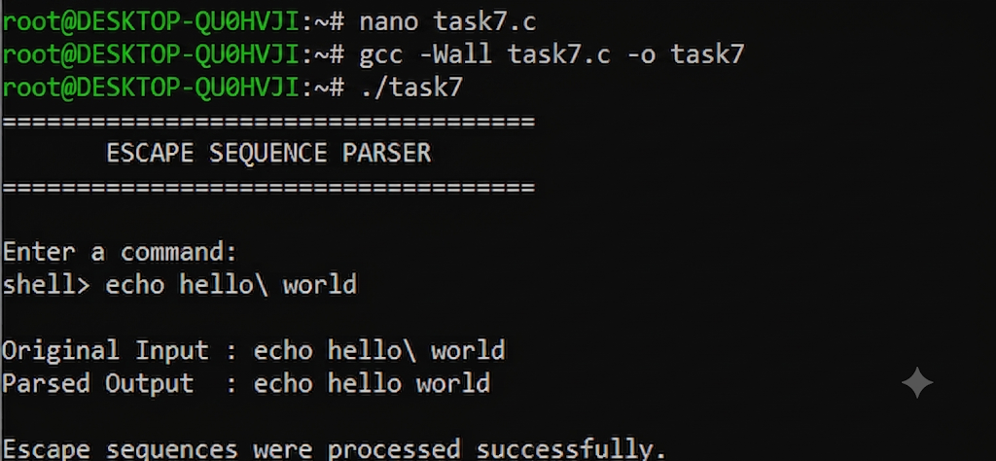

Report: In this task, I implemented escape sequence handling using the backslash character. Escaped spaces and special characters were processed so that they were treated as normal characters. The backslash was removed during parsing while the escaped character was
preserved. Different inputs containing spaces, special symbols, and variables were tested to check the parser output.

Task-2:To Create Child Processes, Execute Programs, Handle Execution Errors, Pass Arguments, Manage Parent Process, Test Command Launching

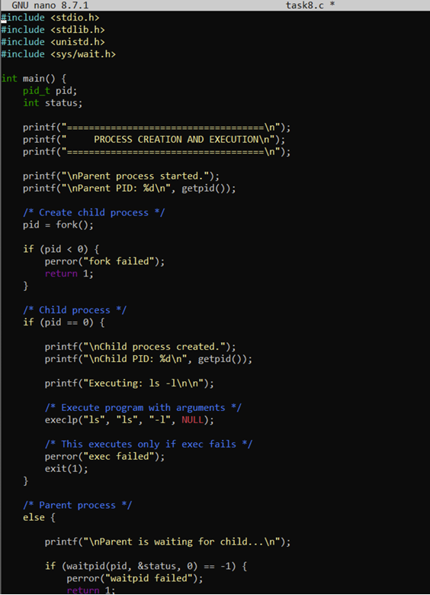

OUTPUT:

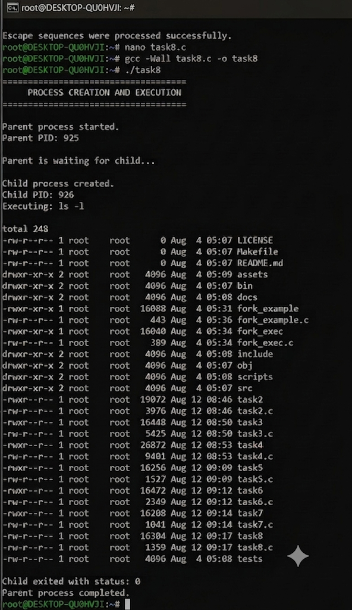

Report: In this task, I implemented process creation and program execution using fork(), exec() and waitpid(). The parent process created a child process, and the child executed the ls
command with arguments using execlp(). The parent waited for the child process to finish and checked its exit status. Error handling was also implemented for cases where the command could not be executed. The program successfully demonstrated process creation, execution,
argument passing, and parent-child process management.

